MODULE 5

Module - 5

TRENDS IN BIOENGINEERING: Muscular and Skeletal Systems as scaffolds, scaffolds and tissue engineering, Bioprinting techniques and materials. Electrical tongue and electrical nose in food science, DNA origami and Biocomputing, Bioimaging and Artificial Intelligence for disease diagnosis. Bioconcrete. Bioremediation. Biomining.

MUSCULAR AND SKELETAL SYSTEM AS SCAFFOLDS:

Skeletal muscle architecture is one of the most important properties that determine a muscle’s force and excursion capability. In the current review, basic architectural terms first are reviewed, and then specific examples relevant to upper extremity anatomy are presented. Specific examples of anatomic considerations required for surgical reconstruction after radial nerve palsy also are detailed. Together, these data show not only the wide variety of architectural designs in human muscles but the importance of considering architectural design when making surgical decisions. The relationship between structure and function in skeletal muscle has been described and probed for more than a century. A classic study has elucidated the microscopic and ultrastructural properties of skeletal muscle fibers, yielding great insights into their function. However, less attention has been given to excellent and insightful studies of the macroscopic properties of skeletal muscle tissues dating back to the 1600s. This macroscopic arrangement of muscle fibers is known as a muscle’s architecture.

Architecture:
The musculoskeletal system (locomotor system) is a human body system that provides our body with movement, stability, shape, and support. It is subdivided into two broad systems:
Muscular system, which includes all types of muscles in the body. Skeletal muscles, in particular, are the ones that act on the body joints to produce movements. Besides muscles, the muscular

system contains the tendons which attach the muscles to the bones.
Skeletal system, whose main component is the bone. Bones articulate with each other and form the joints, providing our bodies with a hard-core, yet mobile, skeleton. The integrity and function of the bones and joints are supported by the accessory structures of the skeletal system; articular cartilage, ligaments, and bursae.

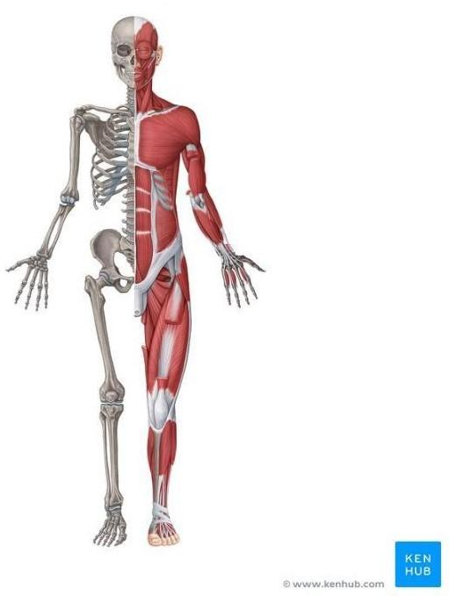
Besides its main function to provide the body with stability and mobility, the musculoskeletal system has many other functions; the skeletal part plays an important role in other homeostatic functions such as storage of minerals (e.g., calcium) and hematopoiesis, while the muscular system stores most of the body's carbohydrates in the form of glycogen.

Mechanism:
The nervous system (your body’s command center) controls your voluntary muscle movements. Voluntary muscles are ones you control intentionally. Some involve large muscle groups to do activities like jumping. Others use smaller movements, like pushing a button.
Movements happen when:
Our nervous system (brain and nerves) sends a message to activate your skeletal (voluntary) muscles. Our muscle fibers contract (tense up) in response to the message. When the muscle activates or bunches up, it pulls on the tendon. Tendons attach muscles to bones. The tendon pulls the bone, making it move. To relax the muscle, your nervous system sends another message. It triggers the muscles to relax or deactivate. The relaxed muscle releases tension, moving the bone to a resting position.
Hundreds of conditions can cause problems with the musculoskeletal system. They can affect the way you move, speak and interact with the world. Some of the most common causes of musculoskeletal pain and movement problems are:

  - Aging

  - Arthritis
  - Back problems
  - Cancer
  - Congenital abnormalities
  - Injuries
  - Osteoporosis
  - Muscular dystrophy

Everyone has pain in their muscles and joints from time to time. One of the most common musculoskeletal conditions is Osteoporosis. More than 60% of people in the United States have Osteoporosis at some point in their lives. Arthritis is also very common. More than 54 million adults in the U.S. have Muscular dystrophy. Most people recover from these disorders without long-term health problems.

BIO-ENGINEERING SOLUTIONS FOR MUSCULAR DYSTROPHY AND OSTEOPOROSIS :

Awareness is increasing that bone morbidity due to osteoporosis is a major complication of Duchenne muscular dystrophy (DMD) and its treatment and that it requires monitoring for early diagnosis and intervention to prevent clinically important sequelae.
The traditional method of fabricating 3D muscle constructs first developed more than 25 years ago involves casting myogenic cells within a cylindrically shaped collagen-I gel that is anchored at the ends to porous felts. In this system, cell-mediated gel compaction and remodeling result in the generation of uniaxial passive stress within the gel, which, in turn, promotes the fusion of myoblasts into myotubes and also myotube alignment. Alternatively, myoblasts, or mixtures of myogenic precursors and fibroblasts, can be cultured on laminin- or hydrogel-coated dishes until spontaneous contractions of formed myotubes detach the entire cell layer, allowing it to self- assemble into a cylindrical tissue construct attached at the ends to premade suture anchors.

Although cell alignment within 3D constructs is not required for the formation of contractile myotubes, it increases fusion efficiency while passive stress promotes both cell survival and myogenesis. In addition to collagen I, different natural hydrogels and their chemically modified derivatives can support the 3D growth and fusion of myogenic cells; the most functional results have been achieved using fibrin-based gels. Carefully optimizing the composition of the fibrin gel to enhance cell-matrix interactions as well as optimizing the starting cell population to improve myogenic fusion and SC maintenance and providing dynamic culture conditions to improve cell survival and maturation have enabled rodent skeletal muscle tissues to be engineered with contractile properties comparable to those of native muscle (e.g., twitch and tetanus-force amplitudes).

Rapid-prototyping techniques for hydrogel molding can be further used to vary local myofiber alignment and to design complex muscle structures, and advanced biomaterials can deliver angiogenic, myogenic, and pro-survival factors to cells in a spatiotemporally controlled fashion. In addition to using biomaterial scaffolds, scaffold-free muscle tissue constructs have been

generated using magnetic fields that allow the controlled assembly of magnetically labeled cells, as well as thermo-responsive polymers that allow controlled cell detachment from culture surfaces.

Although hydrogels have been the dominant muscle-engineering scaffold in vitro, in vivo studiesof muscle repair have mainly utilized acellular natural scaffolds, porous matrices made ofdegradable polymeric materials, or scaffold-free myoblast sheets.

DNA ORIGAMI AND BIOCOMPUTING:

Biological materials are self-assembled with near-atomic precision in living cells, whereas synthetic 3D structures generally lack such precision and controllability. Recently, DNA nanotechnology, especially DNA origami technology, has been useful in the bottom-up fabrication of well-defined nanostructures ranging from tens of nanometers to sub-micrometers. In this Primer, we summarize the methodologies of DNA origami technology, including origami design, synthesis, functionalization and characterization. We highlight applications of origami structures in nanofabrication, nano photonics and nanoelectronics, catalysis, computation, molecular machines, bioimaging, drug delivery and biophysics. We identify challenges for the field, including size limits, stability issues and the scale of production, and discuss their possible solutions. We further provide an outlook on next-generation DNA origami techniques that will allow in vivo synthesis and multiscale manufacturing.

DNA origami is the nanoscale folding of DNA to create arbitrary two- and three-dimensional shapes at the nanoscale. The specificity of the interactions between complementary base pairs makes DNA a useful construction material, through design of its base sequences. DNA is a well- understood material that is suitable for creating scaffolds that hold other molecules in place or to create structures all on its own.

The current method of DNA origami was developed by Paul Rothemund at the California Institute of Technology. The process involves the folding of a long single strand of viral DNA (typically the 7,249 bp genomic DNA of M13 bacteriophage) aided by multiple smaller "staple" strands. These shorter strands bind the longer in various places, resulting in the formation of a pre-defined two- or three-dimensional shape. Examples include a smiley face and a coarse map of China and the Americas, along with many three-dimensional structures such as cubes.

To produce a desired shape, images are drawn with a raster fill of a single long DNA molecule. This design is then fed into a computer program that calculates the placement of individual staple strands. Each staple binds to a specific region of the DNA template, and thus due to Watson-Crick base pairing, the necessary sequences of all staple strands are known and displayed. The DNA is mixed, then heated and cooled. As the DNA cools, the various staples pull the long strand into the desired shape. Designs are directly observable via several methods, including electron microscopy, atomic force microscopy, or fluorescence microscopy when DNA is coupled to fluorescent materials.

Bottom-up self-assembly methods are considered promising alternatives that offer cheap, parallel synthesis of nanostructures under relatively mild conditions.
Since the creation of this method, software was developed to assist the process using CAD software. This allows researchers to use a computer to determine the way to create the correct staples needed to form a certain shape. One such software called caDNAno is an open source software for creating such structures from DNA. The use of software has not only increased the ease of the process but has also drastically reduced the errors made by manual calculations.

Applications:
Many potential applications have been suggested in literature, including enzyme immobilization, drug delivery systems, and nanotechnological self-assembly of materials. Though DNA is not the natural choice for building active structures for nanorobotic applications, due to its lack of structural and catalytic versatility, several papers have examined the possibility of molecular walkers on origami and switches for algorithmic computing. The following paragraphs list some of the reported applications conducted in the laboratories with clinical potential.

Long strands of DNA are folded into a complex scaffold of staple strands having 200–300 nucleotides. This leads to formation of a complex structure that has characteristic features because of their nanoscale dimensions. These DNA nanostrustures are known to still be in their preliminary developmental stages, since key domains, such as their biocompatibility and physiochemical characterizations are yet to be established. However, theoretically, DNA origami has the immense potential to contribute significantly in a wide range of fields, such as diagnosis and drug delivery. Cancer therapy and diagnosis is one such potential domain where DNA origami showed significant anticancer efficacy and may contribute immensely.

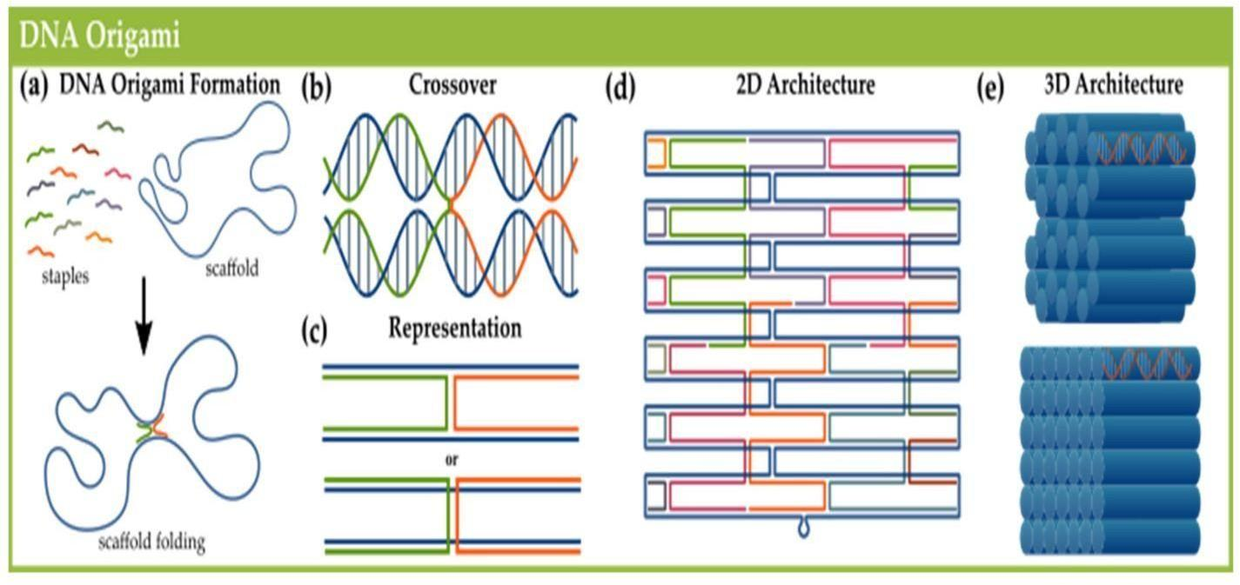

BIOCOMPUTING:

A computer that uses components of biological origin (such as molecules of DNA) instead of electrical components. The device is rudimentary—it can only perform basic high-school-level math problems.

In the quest to understand and model the healthy or sick human body, re searchers and medical doctors are utilizing more and more quantitative tools and techniques. This trend is pushing the envelope of a new field we call Biomedical Computing, as an exciting frontier among signal processing, pattern recognition, optimization, nonlinear dynamics, computer science and biology, chemistry and medicine.
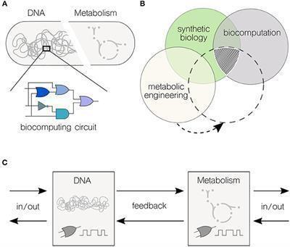
Computing process which use synthesized biological components to store and manipulate data analogous to processes in the human body. The result is small, faster computing processes that operates with great accuracy. Main component used is DNA. The main application is in disease prediction and disease diagnosis.

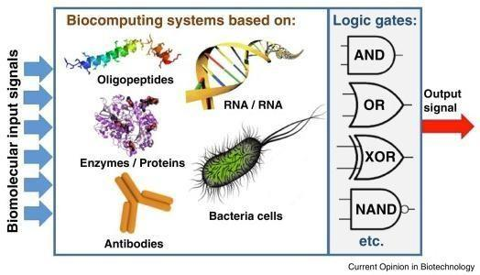

BIOIMAGING AND ARTIFICIAL INTELLIGENCE FOR DISEASE DIAGNOSIS:

BIOIMAGING:

Bioimaging is a noninvasive process of visualizing biological activity in a specific period. It does not inhibit the various life processes such as movement, respiration, etc., and it helps to report the 3D structure of specimens apart from inferencing physically. It is helpful in connecting the observation of subcellular structures and all the tissues in the multicellular organisms.
The imaging of biological samples, or bioimaging, plays a key role in current life science research, enabling scientists to analyze molecules, cells and tissues from a range of living systems.
Nanoparticle fluorescence imaging has been used in gene detection, protein analysis, enzyme activity evaluation, element tracing, cell tracking, early stage disease diagnosis, tumor related research, and monitoring real time therapeutic effects.
Bioimaging spans the observation of subcellular structures and entire cells over tissues up to entire multicellular organisms. Among others, it uses light, fluorescence, electrons, ultrasound, X-ray, magnetic resonance and positrons as sources for imaging.

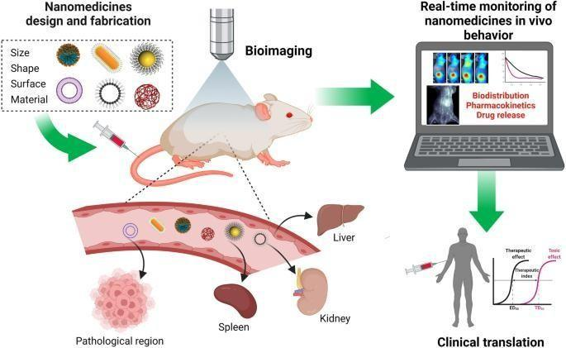

- ARTIFICIAL INTELLIGENCE IN DISEASE DIAGNOSIS: 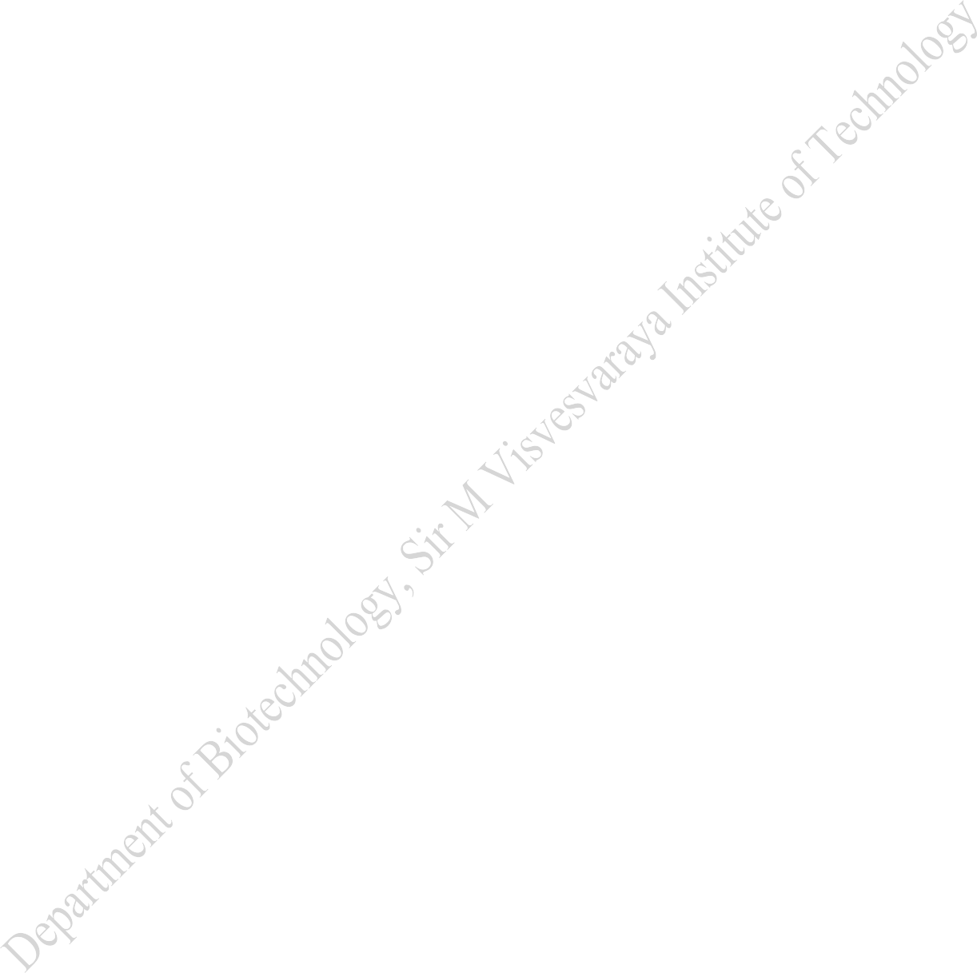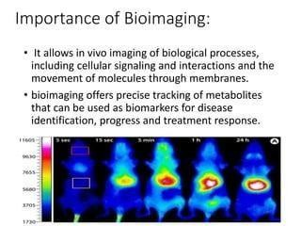

Artificial intelligence can assist providers in a variety of patient care and intelligent health systems. Artificial intelligence techniques ranging from machine learning to deep learning are prevalent in healthcare for disease diagnosis, drug discovery, and patient risk identification. Numerous medical data sources are required to perfectly diagnose diseases using artificial intelligence techniques, such as ultrasound, magnetic resonance imaging, mammography, genomics, computed tomography scan, etc. Furthermore, artificial intelligence primarily enhanced the infirmary experience and sped up preparing patients to continue their rehabilitation at home.

Detecting any irresistible ailment is nearly an afterward movement and forestalling its spread requires ongoing data and examination. Hence, acting rapidly with accurate data tosses a significant effect on the lives of individuals around the globe socially and financially (Minaee et al. 2020). The best thing about applying AI in health care is to improve from gathering and processing valuable data to programming surgeon robots.
AI describes the capability of a machine to study the way a human learns, e.g., through image identification and detecting pattern in a problematic situation. AI in health care alters how information gets composed, analysed, and developed for patient care.

System planning is the fundamental abstract design of the system. It includes the framework’s views, the course of action of the framework, and how the framework carries on underneath clear

conditions. A solid grip of the framework design can help the client realize the limits and boundaries of the said framework. In pre-preparing, real-world information requires upkeep and pre-preparing before being taken care of by the calculation. Because of the justifiable explanation, real-world data regularly contains mistakes regarding the utilized measures yet cannot practice such blunders. Accordingly, information pre-preparing takes this crude information, cycles it, eliminates errors, and spares it an extra examination. Information experiences a progression of steps during pre-handling: Information is purged by various strategies in information cleaning.
These strategies involve gathering information, such as filling the information spaces that are left clear or decreasing information, such as the disposal of commas or other obscure characters. In information osmosis, the information is joined from a combination of sources.

The information is then amended for any blend of mistakes, and they are quickly taken care of. Information Alteration: Data in this progression is standardized, which depends upon the given calculation. Information standardization can be executed utilizing several ways. This progression is obligatory in most information mining calculations, as the information wants to be as perfect as possible. Information is then mutual and developed.

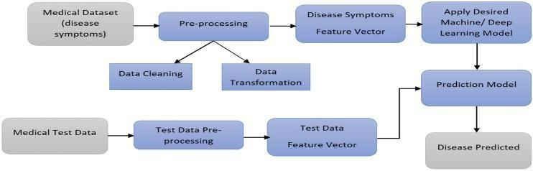
SELF HEALING BIOCONCRETE:

Bio-concrete is a self-healing form of concrete designed to repair its own cracks.
To heal cracks in the concrete, Jonkers chose bacteria (Bacillus pseudo?rmus and B. cohnii), that are able to produce limestone on a biological basis. The positive side-effect of this property: the

bacteria consume oxygen, which in turn prevents the internal corrosion of reinforced concrete. However, the bacteria do not pose a risk to human health, since they can only survive under the alkaline conditions inside the concrete. Based on these findings, Jonkers and his team of researchers developed three different bacterial concrete mixtures: self-healing concrete, repair mortar, and a liquid repair system.

In self-healing concrete, bacterial content is integrated during construction, while the repair mortar and liquid system only come into play when acute damage has occurred on concrete elements. Self-healing concrete is the most complex of the three variants. Bacterial spores are encapsulated within two-to four-millimeter wide clay pellets and added to the cement mix with separate nitrogen, phosphorous and a nutrient agent. This innovative approach ensures that bacteria can remain dormant in the concrete for up to 200 years. Contact with nutrients occurs only if water penetrates into a crack – and not while mixing cement. This variant is well-suited for structures that are exposed to weathering, as well as points that are difficult to access for repair workers. Thus, the need for expensive and complex manual repairs is eliminated.

Self-healing concrete is nothing but concrete which can retain itself to the original state when it is subjected to cracks." Bio-concrete is a material that will biologically produce minerals like limestone with the help of bacteria present in it, which will heal cracks that appear on the concrete surfaces.Bacterial self-healing is an innovative technology allowing repairing open micro-cracks in concrete by CaCO3 precipitation. This bio-technology improves the durability of the structure. In this paper, peptone, yeast extract and Bacillus Subtilis were added as microbial adjuvant in concrete mix design.
Rahbar predicts self-healing concrete could extend the life of a structure from 20 years, for example, to 80 years. Other research into creating self-healing concrete has focused on adding microbes and Bacillus megaterium, a spore-forming bacteria that produces an enzyme that is expelled into the concrete mix.

The healing agent consisting of B. cohnii spores, calcium lactate and yeast extract immobilized in light-weight aggregates was also combined with cement, fly ash, limestone powder,PVA fibers,water in a repair mortar.
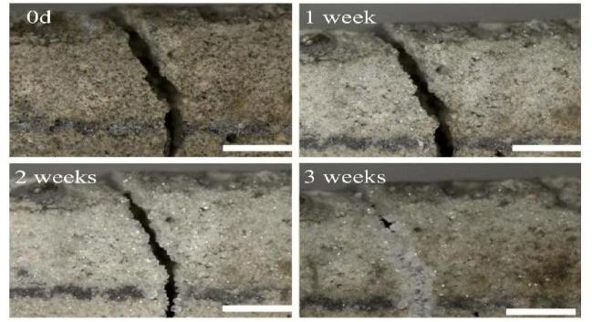
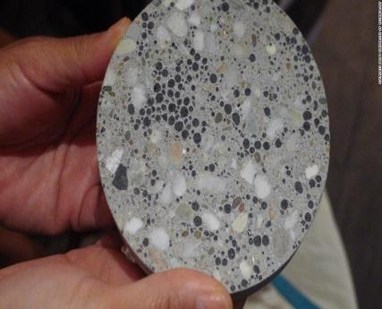

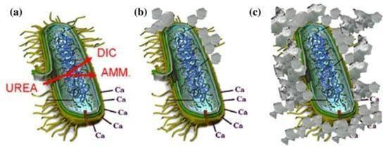

BIOREMEDIATION AND BIO MINING VIA MICROBIAL SURFACE ADSORPTION:

1) BIOREMEDIATION:

Bioremediation is a biotechnical process, which abates or cleans up contamination. It is a type of waste management technique which involves the use of organisms to remove or utilize the pollutants from a polluted area.
Types of Bioremediation Bioremediation is of three types –

- Biostimulation:
As the name suggests, the bacteria is stimulated to initiate the process. The contaminated soil is first mixed with special nutrients substances including other vital components either in the form of liquid or gas. It stimulates the growth of microbes thus resulting in efficient and quick removal of contaminants by microbes and other bacterias.

- Bioaugmentation:
At times, there are certain sites where microorganisms are required to extract the contaminants. For example – municipal wastewater. In these special cases, the process of bioaugmentation is used. There’s only one major drawback in this process. It almost becomes impossible to control the growth of microorganisms in the process of removing the contaminant.

- Intrinsic Bioremediation:
The process of intrinsic bioremediation is most effective in the soil and water because of these two biomes which always have a high probability of being full of contaminants and toxins. The process of intrinsic bioremediation is mostly used in underground places like underground petroleum tanks. In such place, it is difficult to detect a leakage and contaminants and toxins can find their way to enter through these leaks and contaminate the petrol. Thus, only microorganisms can remove the toxins and clean the tanks.

Bioremediation helps clean up water sources, create healthier soil, and improve air quality around the globe. But unlike excavation-based remediation processes, which can be disruptive, bioremediation is less intrusive and can facilitate remediation of environmental impacts without damaging delicate ecosystems.

Immobilization of microbial cells and enzymes by adsorption takes place through their physical interaction with the surface of water-insoluble carriers. This method, commonly used in bioremediation processes, is quick, simple, eco-friendly and cost-effective.
Microorganisms are utilized in bioremediation because of their ability to degrade environmental pollutants due to their metabolism via biochemical pathways related to the organism’s activity and growth.

- BIOMINING:

Biomining is the process of using microorganisms (microbes) to extract metals of economic interest from rock ores or mine waste. Biomining techniques may also be used to clean up sites that have been polluted with metals.

Valuable metals are commonly bound up in solid minerals. Some microbes can oxidize those metals, allowing them to dissolve in water. This is the basic process behind most biomining, which is used for metals that can be more easily recovered when dissolved than from the solid rocks. A different biomining technique, for metals which are not dissolved by the microbes, uses microbes to break down the surrounding minerals, making it easier to recover the metal of interest directly from the remaining rock.

Most current biomining operations target valuable metals like copper, uranium, nickel, and gold that are commonly found in sulfidic (sulfur-bearing) minerals. Microbes are especially good at oxidizing sulfidic minerals, converting metals like iron and copper into forms that can dissolve more easily. Other metals, like gold, are not directly dissolved by this microbial process, but are made more accessible to traditional mining techniques because the minerals surrounding these metals are dissolved and removed by microbial processes. When the metal of interest is directly dissolved, the biomining process is called “bioleaching,” and when the metal of interest is made more accessible or “enriched” in the material left behind, it is called “biooxidation.” Both processes involve microbial reactions that can happen anywhere the microbes, rocks, and necessary nutrients, like oxygen, occur together.

Bioleaching (or biomining) is a process in mining and biohydrometallurgy (natural processes of interactions between microbes and minerals) that extracts valuable metals from a low-grade ore with the help of microorganisms such as bacteria or archaea.
Instead of separating the metal from the pyrite with high temperatures or pressures, biomining uses microbes from the Acidthiobacillus and Leptospirillum genera to do the job.

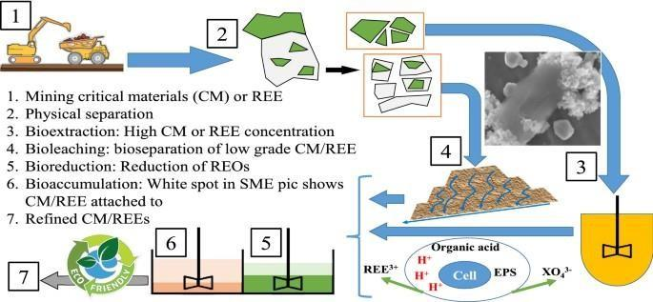

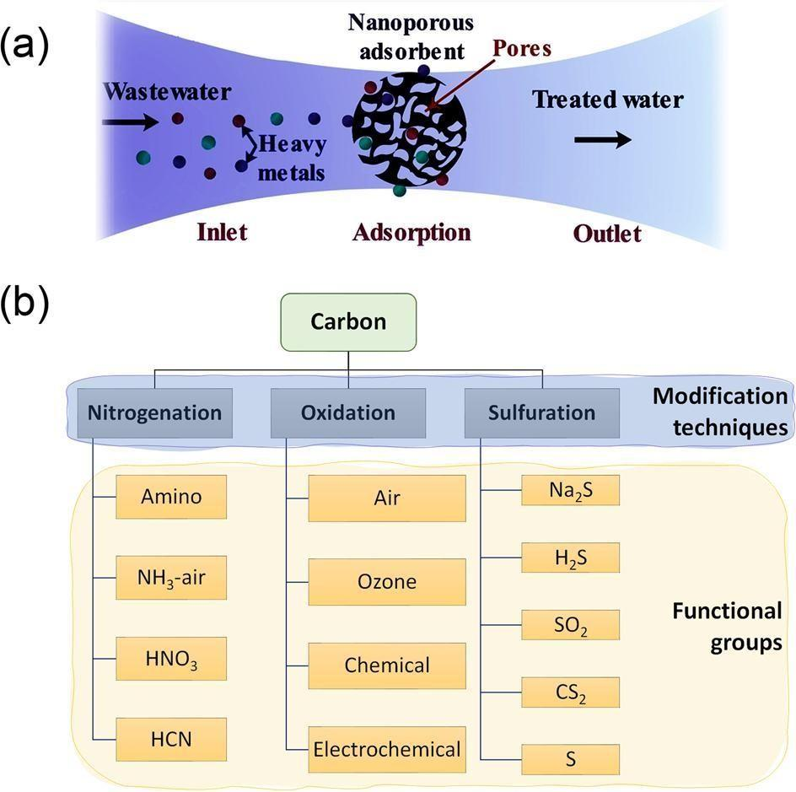

  - Heavy metal ions adsorption process; the metal ions of wastewater adhere to the surface of nanoporous adsorbents, which has a high surface area due to its porosity. The adsorption

process could be selective for one or more metals than others. The regeneration processcould be achieved using a desorbing agent.

  - Various modification techniques (i.e., nitrogenation, oxidation, and sulfuration) are used to functionalize carbon with different functional groups. Functionalization enhances adsorption capacity and stability.

